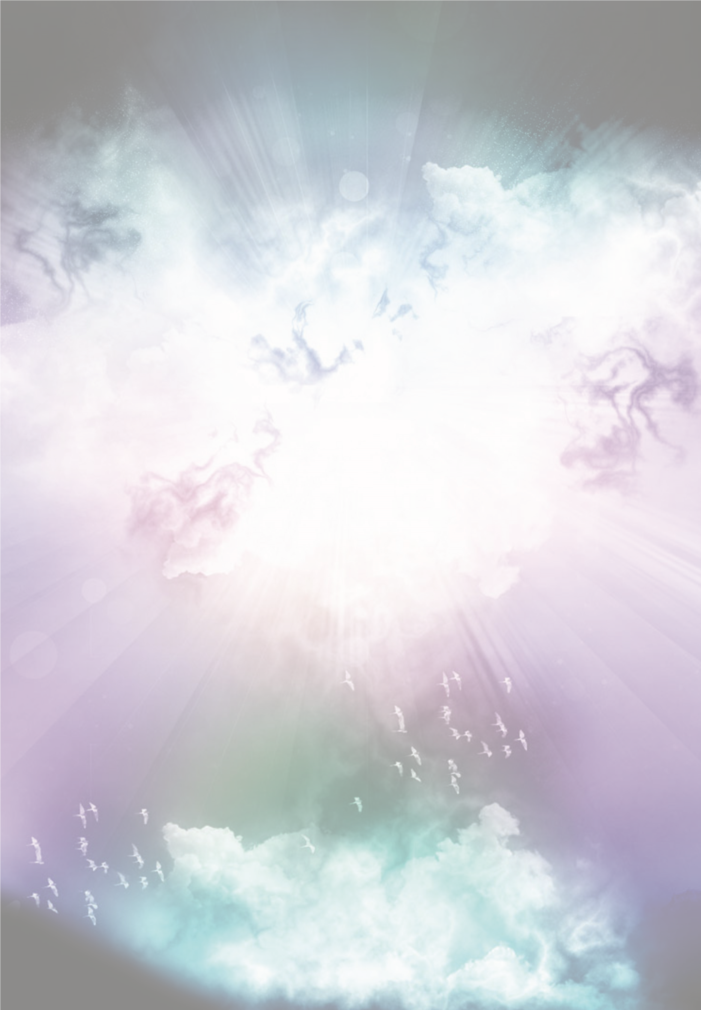
Working with the
Wisdom of our Dreams

An experiential workshop with Kathleen Duffy
- Venue: La Verna Centre, Franciscan House, Ballinderry, Mullingar, Co. Westmeath
- Date: Saturday March 25th 2017
- Time: 10am to 5pm

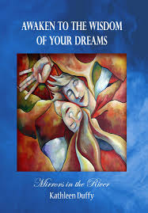
This very popular workshop invites participants to experience the amazing wisdom of Dreams
as a powerful source of Guidance from the Soul.

It offers practical experience of how to make sense of the unconscious wisdom we often dismiss through lack of understanding of this ancient dream language.

‘For God does speak to us, now one way, now another, though man may not perceive it, in a dream, in a vision of the night when deep sleep falls on men as they slumber in their beds, he opens their ears and gives them instruction’. Job 33: 14-16

Participants will gain an understanding of the psyche and its functioning, as well as an opportunity to explore the irrational nature of the dream in bringing unconscious content to consciousness.

Kathleen will also;
- Introduce you to the language of the dream, which is that of symbol, myth, ritual, imagination and story.
- Explore some of the major Archetypes of the psyche.
- Teach you how to discern when to take dream wisdom literally or symbolically.
- Work with why we have recurring dreams, and what happens when we ignore them and they turn into nightmares.
- Examine the difference between personal and universal symbols.
- Show you how to befriend the unconscious, and listen to, record, and work with dream wisdom in order to
benefit from this guidance in everyday life.
For further information, you can see her web page at www.awakentoyourdreams.com

Cost for the day €60 Euro which includes tea/coffee and a light lunch

For booking contact: La Verna Centre, Franciscan House, Ballinderry, Mullingar, Co. Westmeath
Or phone on 044-93-52000
A Deposit of €20 (non-refundable) is requested please

[Cite your source here.]

